ADVANCED CYBERSECURITY CONCEPTS

ASSIGNMENT THOREY1

TASK1: Draw a simple network diagram for a music streaming startup like Spotify, showing at least 4 segments (e.g., user devices, web servers, database, admin panel). Label each segment clearly.
Step 1: Understand the network segments
Segment | Purpose
1. User Devices | Mobile phones, laptops, and tablets used by customers.
2. Web Servers | Handle website requests, login requests, and music streaming requests.
3. Database | Stores user details, playlists, subscriptions, and account information.
4. Admin Panel | Used by authorized employees to manage the system.
5. Firewall | Controls traffic between network segments.

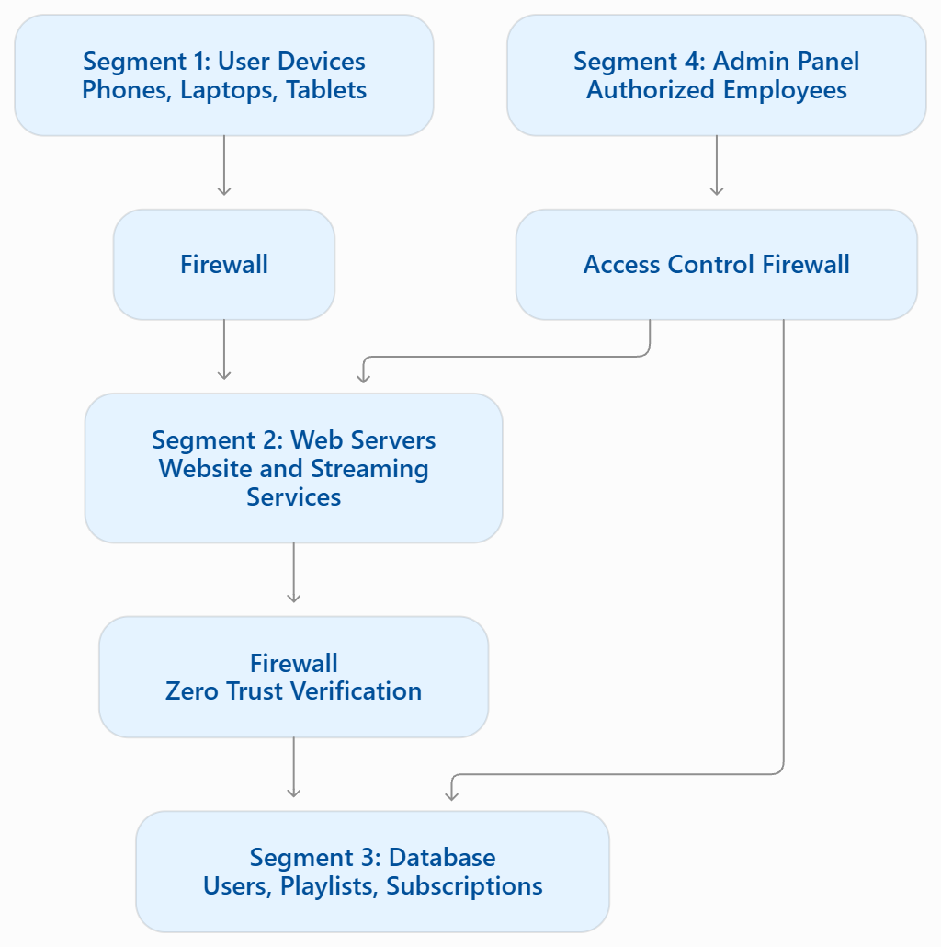
Step 3: How to draw it in draw.io
- Open draw.io (diagrams.net).
- Select Device to save your diagram on your computer.
- Select Create New Diagram.
- Choose Blank Diagram.
- Drag rectangles from the left-side shape panel.
- Create separate boxes for User Devices, Web Servers, Database, and Admin Panel.
- Add firewall symbols or rectangles between the segments.
- Connect the boxes using arrows.
- Add labels to every segment.
- Save your diagram.
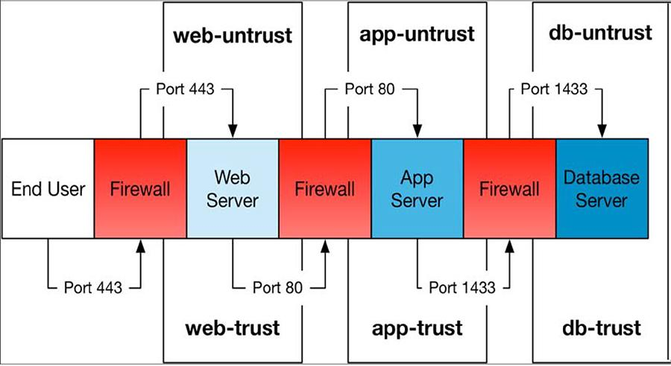

TASK2: Write a Zero Trust access policy for the admin panel segment in your diagram, specifying which roles (e.g., support staff, engineers) can access it and what minimum privileges they should have.<br><br><em><strong>Hint:</strong> Apply the 'least privilege' principle—only give access needed for each role's tasks.</em>
Step 1: What is Zero Trust?
Zero Trust means "Never Trust, Always Verify."
Step 2: Create an access policy
Employee role | Access permission | Minimum privileges
Support Staff | Limited admin panel access | View customer accounts and help with basic account issues.
Engineers | Technical access | Manage application settings and troubleshoot services.
Security Team | Security access | Review security logs and investigate threats.
Administrator | Full administrative access when required | Manage users, permissions, and system settings.

Step 3: Apply security rules
- Every employee must log in using their own account.
- Enable Multi-Factor Authentication (MFA).
- Give employees only the permissions needed for their work.
- Do not allow support staff to change server or database settings.
- Engineers should not automatically receive access to customer data.
- Record and monitor admin panel activities.
- Review employee permissions regularly and remove access when it is no longer needed.

Zero Trust Access Policy for Admin Panel
Zero Trust follows the principle of "Never Trust, Always Verify." Every employee must verify their identity before accessing the admin panel.
- Support Staff: Can view customer accounts and help with basic account problems. They cannot change system settings.
- Engineers: Can access technical settings and manage application services. Database access is allowed only when required for their work.
- Security Team: Can view security logs, monitor activities, and investigate security problems.
- Administrators: Can manage users, permissions, and system settings. Their access must be controlled and monitored.
All employees must use strong passwords and Multi-Factor Authentication (MFA). Access should be given according to job responsibilities. This follows the principle of least privilege and protects the admin panel from unauthorized access.

TASK3: Describe how you would use micro-segmentation to protect the user data segment in your network diagram. List two benefits this provides over a traditional flat network.
Step 1: What is Micro-Segmentation?
Micro-segmentation means dividing a network segment into smaller, separate parts and applying security rules to each part.
For example, the database segment can be divided into:
- User Account Database
- Playlist Database
- Subscription Database
- Payment Information Database
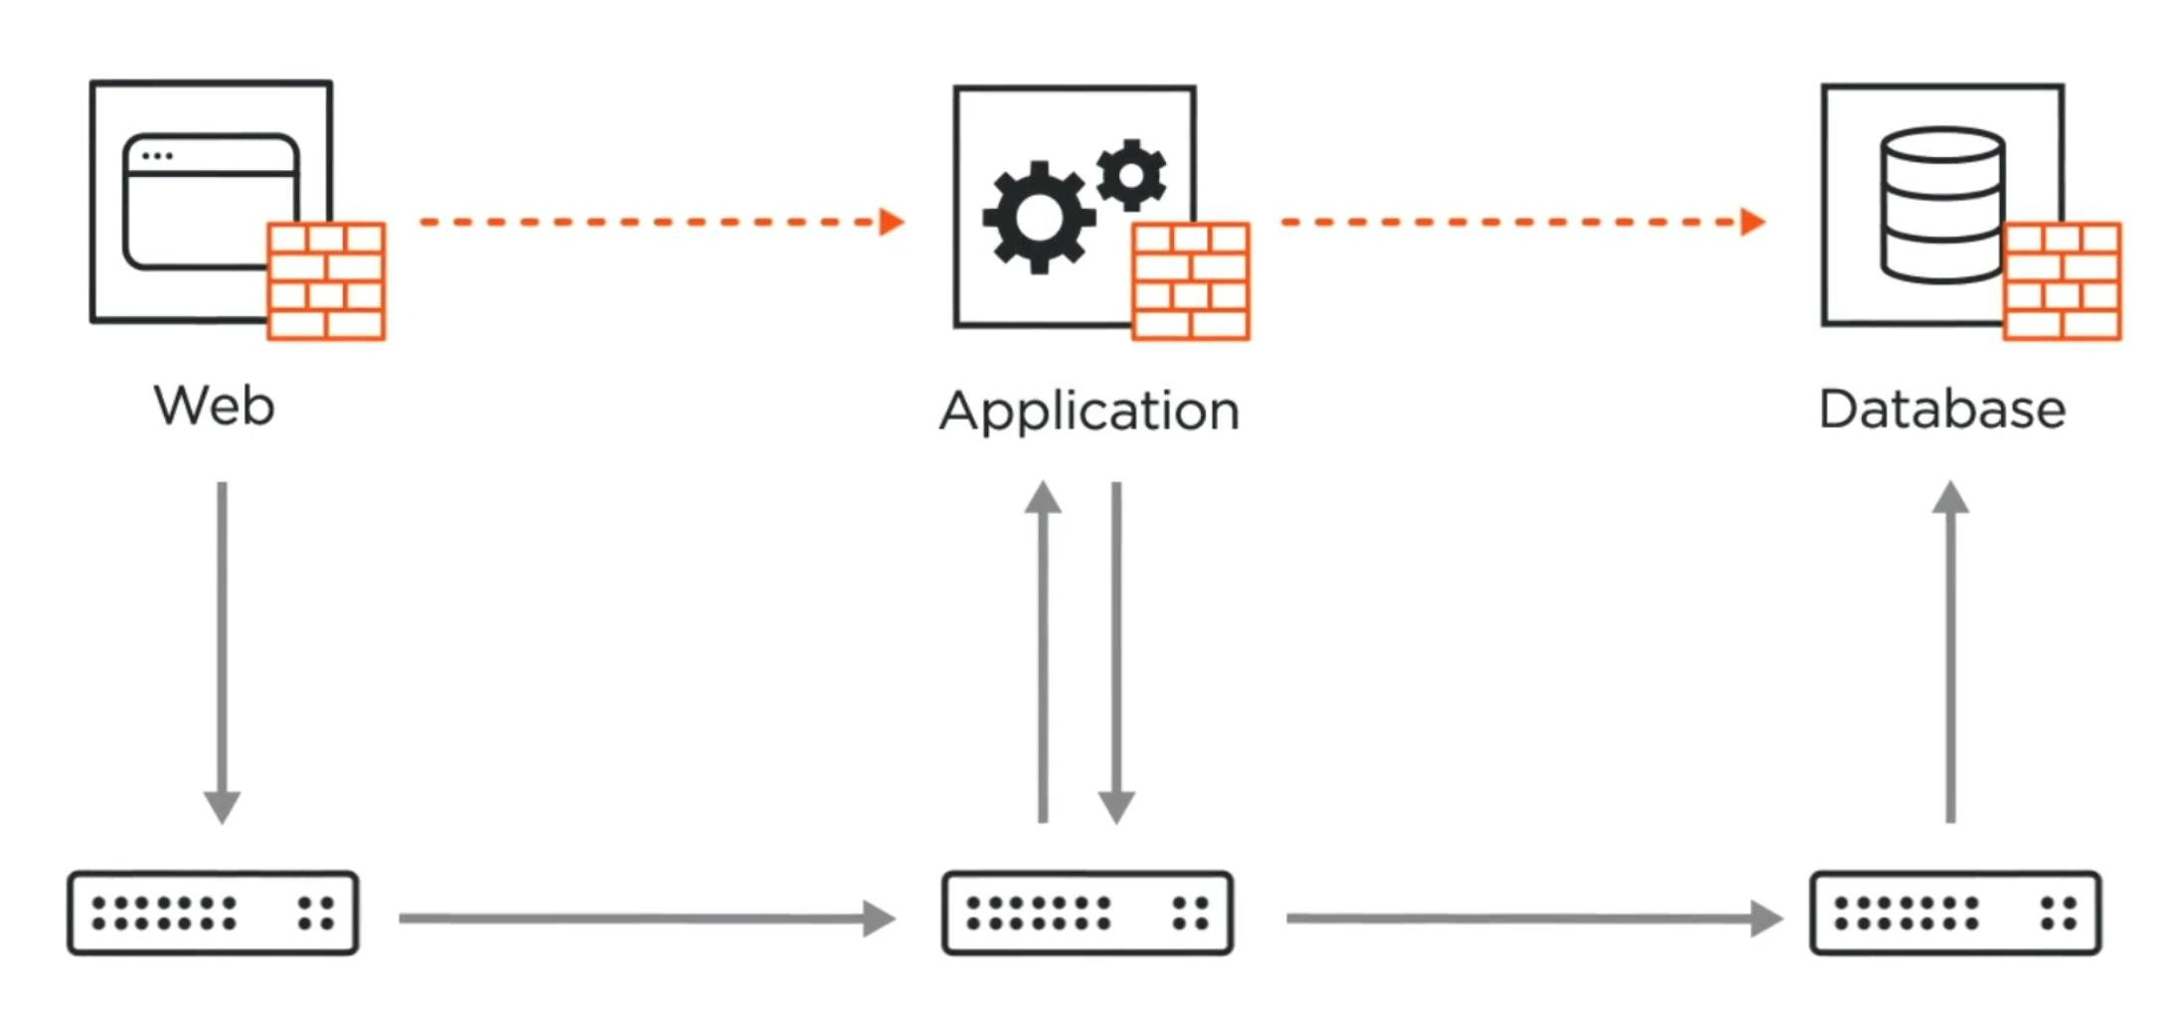
Step 2: How would you use it?
- Divide the database into smaller sections.
- Keep customer account information separate from payment information.
- Allow only authorized applications to access each database section.
- Block unnecessary connections between database sections.
- Monitor access and record suspicious activity.
Step 3: Two benefits over a traditional flat network
Benefit | Explanation
1. Better security | If attackers enter one section, they cannot automatically access all other sections.
2. Limited damage | It reduces the spread of malware and unauthorized access across the network.

TASK4: Using any free online diagram tool (like draw.io or Lucidchart), simulate adding a new firewall rule to enforce 'Never Trust, Always Verify' between the web server and database segments. Take a screenshot and submit it.

